**Task: Create a SQL DB in portal and set a firewall rule.**

Step1: Create a SQL DB.

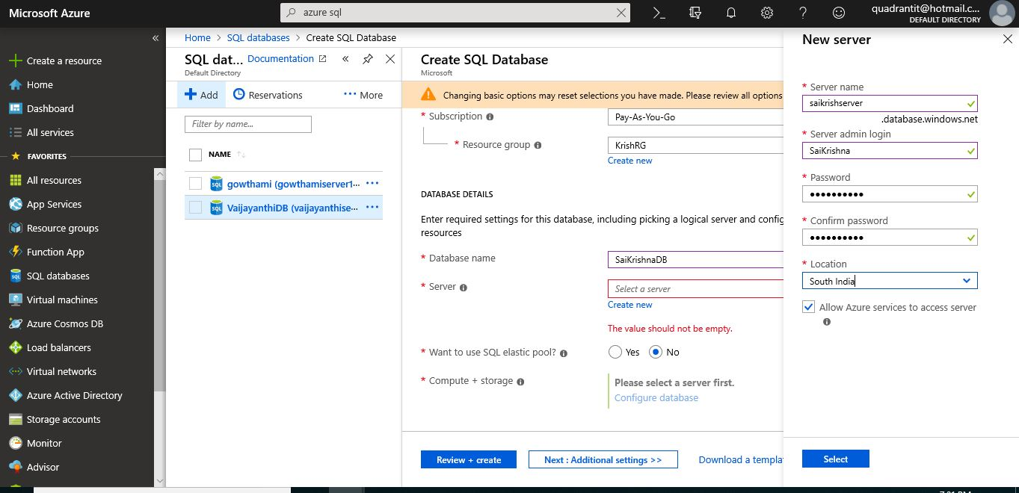

**Step2: Deploy It.**

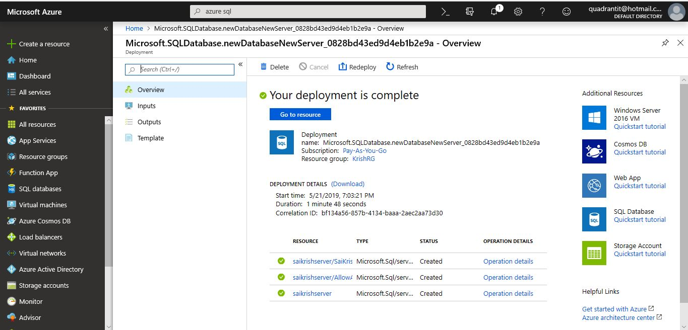

**Step3: Setup firewall rules.**

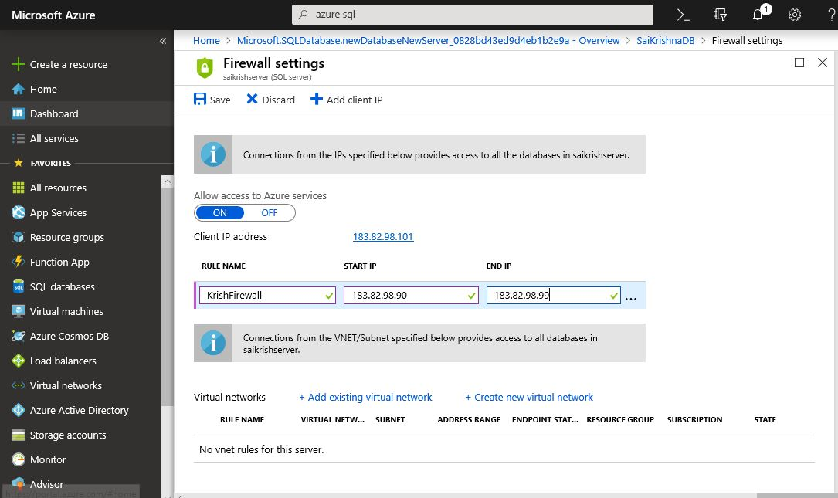

**Step4: Firewall settings Succeded.**

